Student Name : Pyae Phyo Aung
Student PRN : 0526017003
Class : AI Compute Platforms, Applications and Trends
Assignment Title : Assignment I
GitHub Repository Link : https://github.com/learncloudhub/student-grade.git

Screenshot 1 – Local Repository
Show:
• The student-grade folder
• The source-code file
• The Git Bash terminal

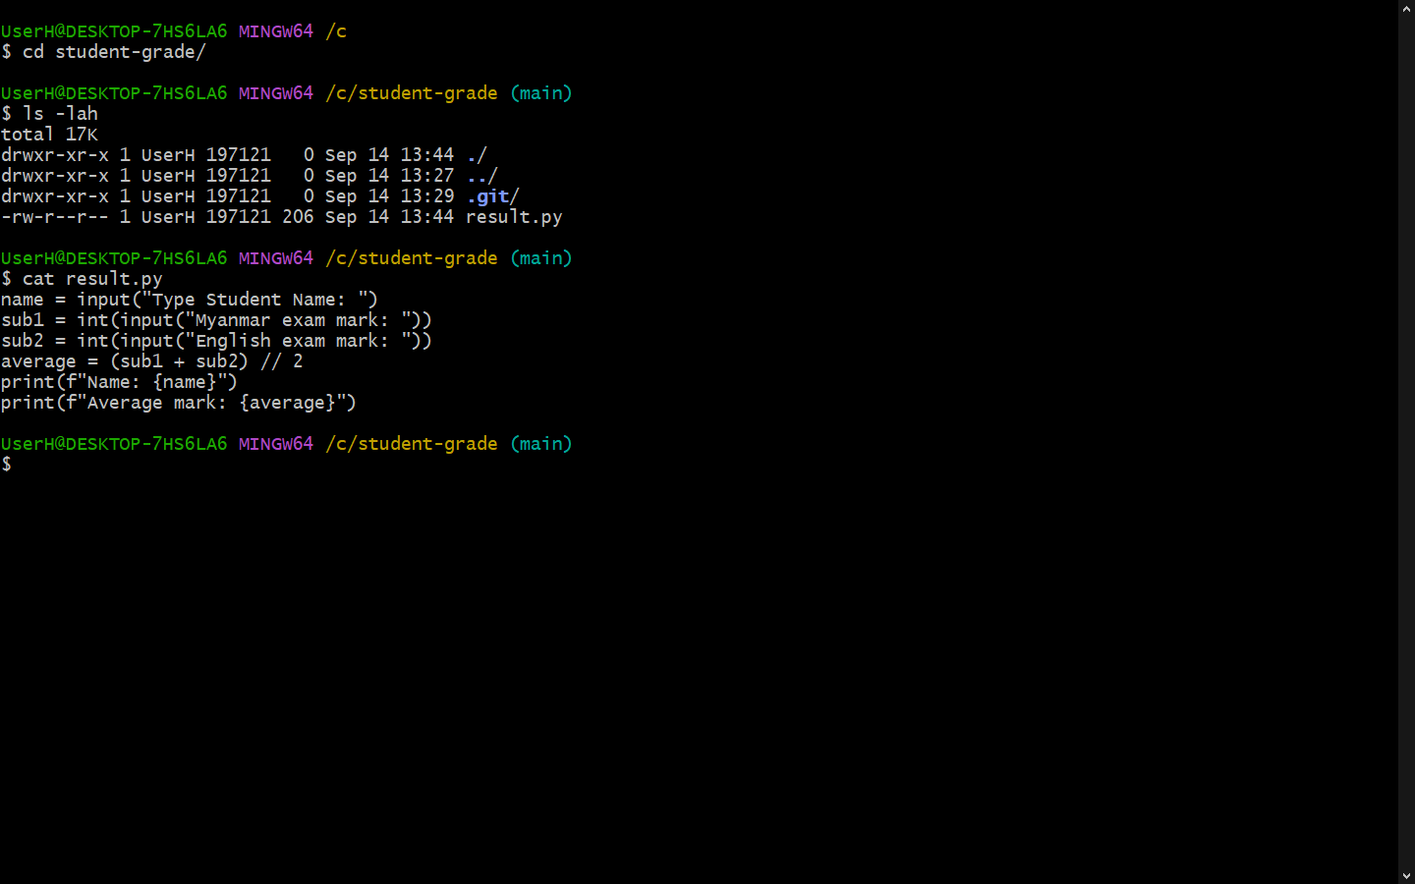

Screenshot 2 – Git Initialization and First Commit
Show the Git commands used to:
• initialize the repository
• check repository status
• add the file
• commit the file
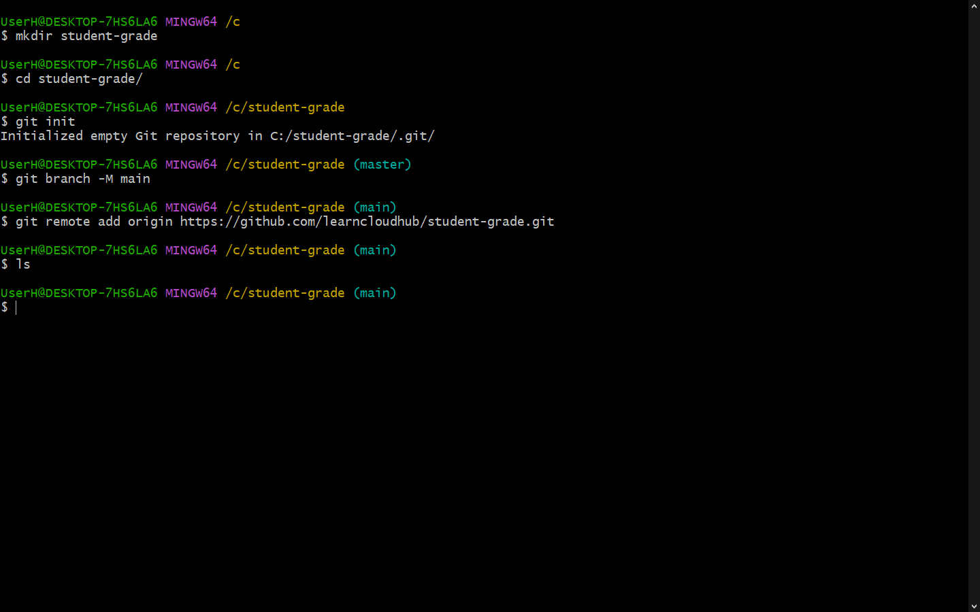
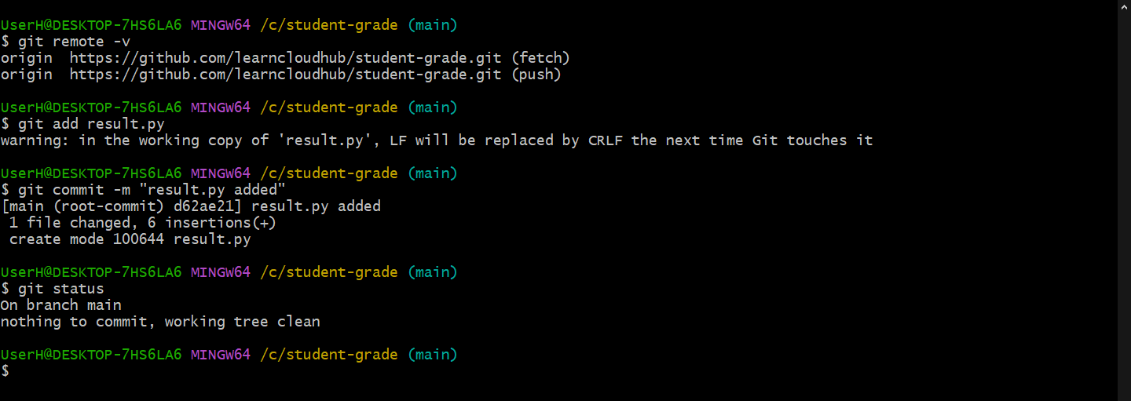

Screenshot 3 – Commit History
Show the output of:
git log –oneline
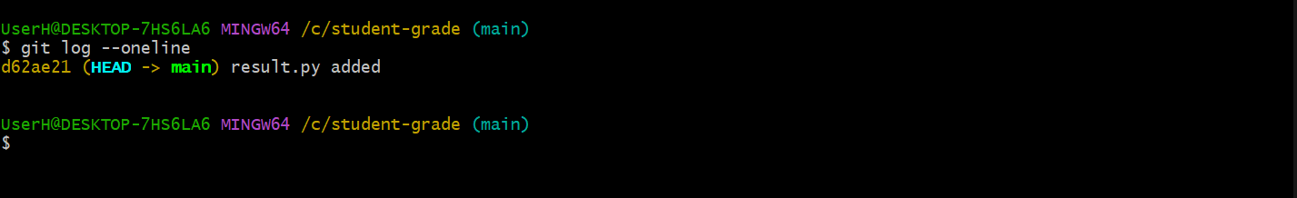

Screenshot 4 – Remote Repository Connection
Show the output of:
git remote –v
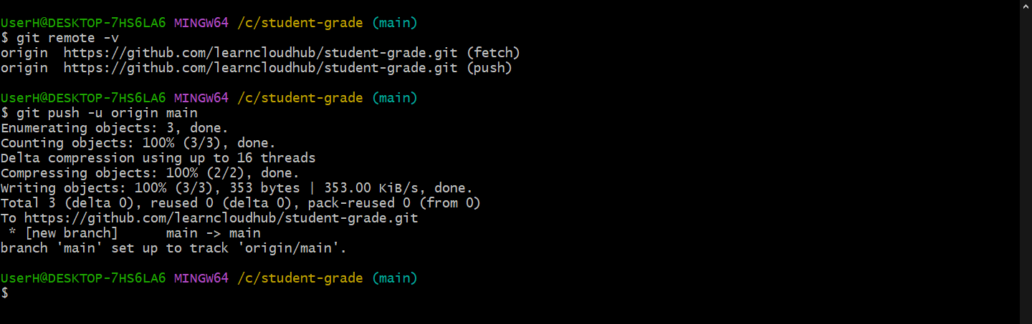

Screenshot 5 – First GitHub Push
Show the GitHub repository containing the original Student Grade Program.
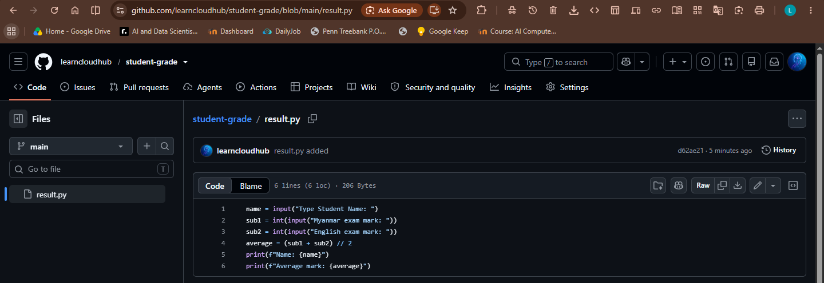

Screenshot 6 – GitHub Modification
Show the modification made directly on GitHub for the Pass/Fail result.
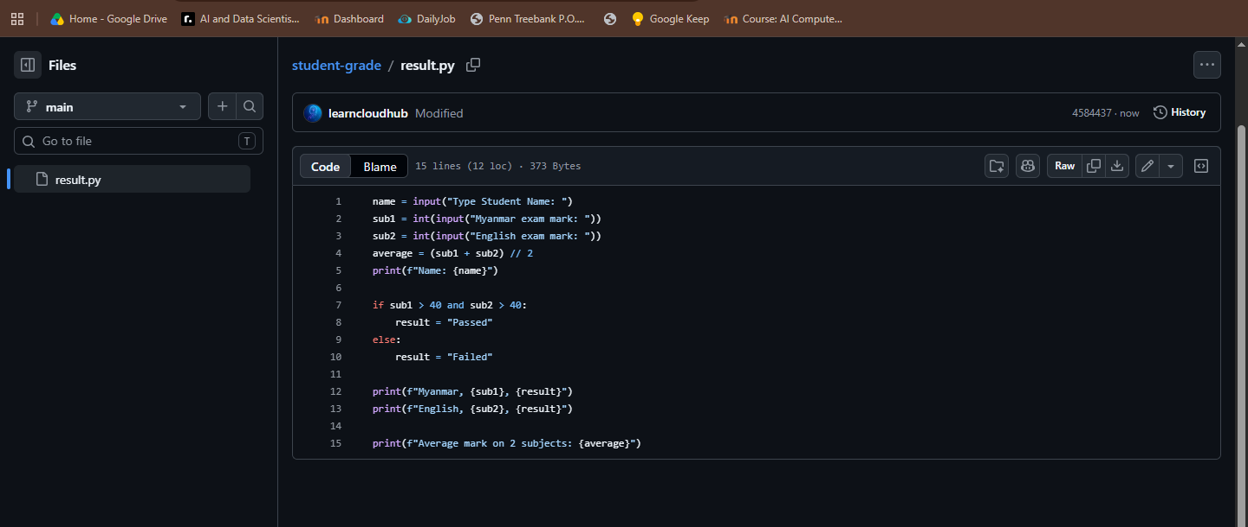

Screenshot 7 – Local Modification
Show the local program containing the Total Mark modification.
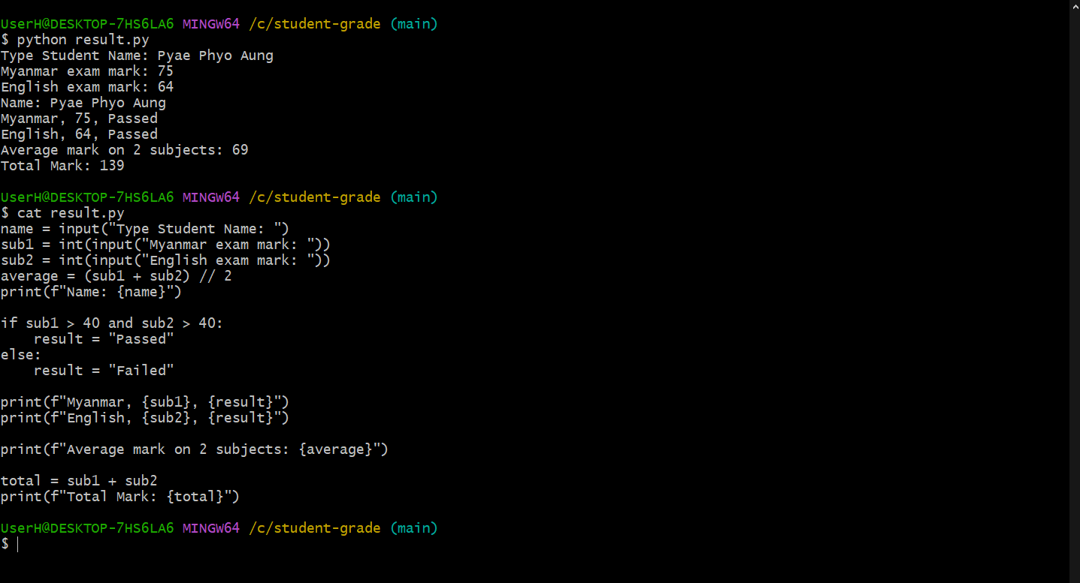
Screenshot 8 – Push Result
Show the Git Bash output when attempting to push after both the local and remote
repositories have been modified.

Fig1.0, Conflict
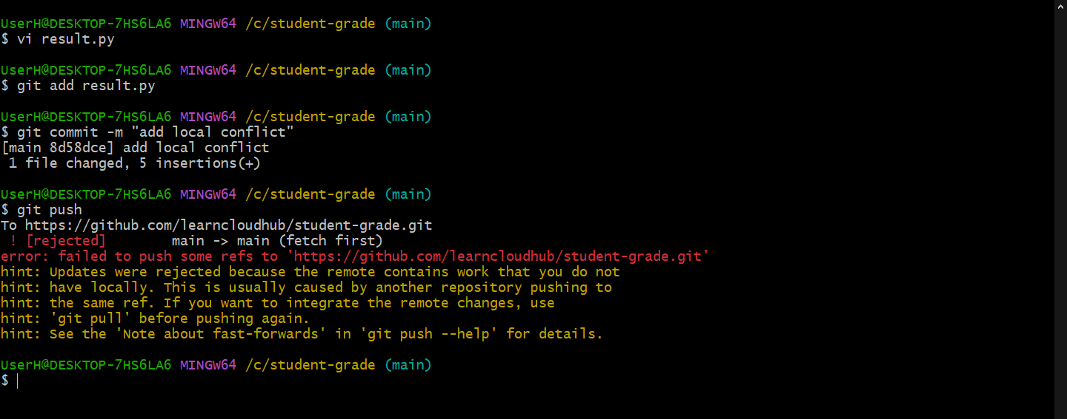

Fig2.0, Merge conflict
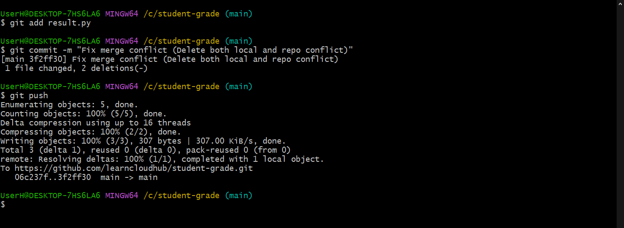

This is because when we made both local changes and repo changes at the same time without push or pull. So pull from repo first and them merge and push the file to the repo again and conflict will be resolved.

Screenshot 10 – Final Program
Show the final program running successfully with:
Student Name
Total Mark
Average Mark
Pass / Fail Result
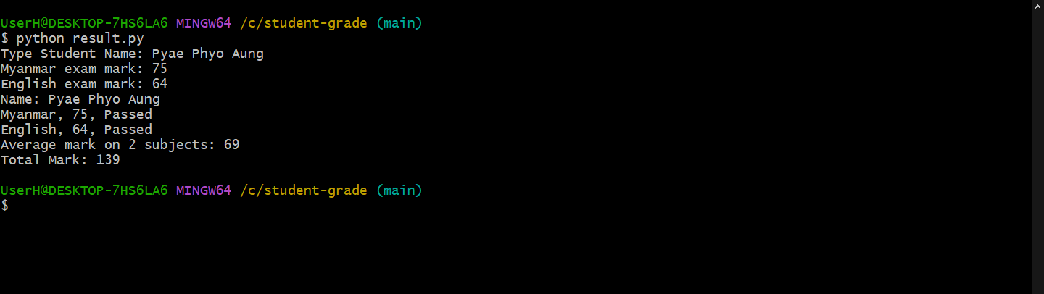

Screenshot 11 – Final GitHub Repository
Show the final source code in the GitHub repository.
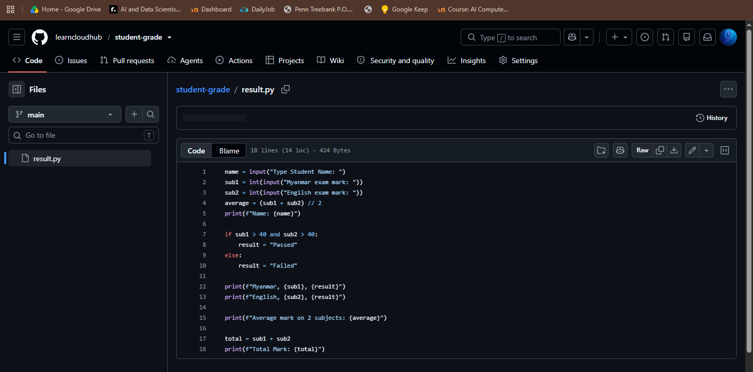

Screenshot 12 – Final Commit History
